**Stretchable Polymeric Gel-Based Sponge with On-demand Adjustable Wettability**

*----*

a Interface Materials and Chemical Engineering Research Center, Korea Research Institute of Chemical Technology (KRICT), 141 Gajeong-ro, Yuseong-gu, Daejeon 34114, South Korea.

**Corresponding Author**

*E-mail ()

**Abstract**

abc

**Introduction**

1. [기존 연구, 스폰지 matrix 를 타겟으로 두어야 함.] 기존 연구에서는 다양한 물질로 스폰지를 제작 (기공을 이용하거나 늘어나는?), 이를 matrix로 사용하여 액체를 함침 할 수 있는 특성을 이용, 물/기름 분리, 센서, 등등등 이용하였다.
2. 하지만 기존 연구에서 사용한 일반적인 스폰지 matrix는 스트레처블 을 중점으로 하였을 때는 (PDMS 기반이거나, PUA?, 우레탄) 를 사용하거나, 표면 wetting을 조절하는 응용 목적이었으면 UV (azo), pH 변화(copolymer ion?)에 따른 wetting 변화를 기반으로 스폰지 matrix 를 제작하였음. 외부 특정 조건에서만 원하는 surface energy를 달성할 수 있고 (+외부 자극/환경에 의해서만 발현된다.)(의도치 않게 wetting 이 변할 수 있다.) 또, 기존은 스트레처블 함과 동시에 원하는 surface energy를 영구적으로 sponge matrix를 만들 수 있는 연구는 아직 이루어지지 않았다. (하지만 스트레처블하면서 동시에 원하는 형태로 wetting systematic 하게 control 할 수 있는 형태는 개발되지 못하였다. ~~?)
3. 우리는 XX 새로운? 스폰지 matrix용 신물질을 합성하였다. 이 물질은 (1) 잘 늘어나고, (2) 투명하고, (3) hydrophilic하고 hydrophobic한 moiety를 쉽게 넣을 수 있어서 wettability를 원하는 형태(on-demand) 로 영구적으로 조절 가능하다. 이를 스폰지 matrix로 응용하였을 시 기존 연구 (PDMS sponge) 보다 대략 XXX 까지 더 늘어나고 동시에
4. 이 장점을 증명하기 위해서 물/기름 분리 소재로 응용, strain sensor 로 응용

Figure 1: 우리 물질의 장점 특징 소재  
Figure 2: 스폰지로 제작  
Figure 3: 스폰지 응용 (물/기름 분리)  
Figure 4: 스폰지 응용 (strain sensor)

Here, we demonstrate a strategy to fabricate a wide range of hierarchical structures by precisely controlled three-dimensional (3D) photoengraving the individual surfaces of micropillar arrays made of azopolymers. Our approach has created new opportunities for manipulating and mimicking the intrinsically multiscale, multimaterial and multifunctional structures. The azopolymers consist of a polymeric host impregnated with photoresponsive azobenzene molecules. In our study, disperse orange 3 and bisphenol A diglycidyl ether are polymerized together, referred as PDO 3 (**Figure S1**).18,24,25 When exposed to two interference laser beams, PDO 3 films are spontaneously photoengraved with periodic line patterns as the surface-relief-gratings (SRG) (**Figure S2**). By exercising additional degrees of control over light irradiation vectors and using 3D azopolymer scaffolds instead of a flat surface, we are able to engrave 1D lines and two-dimensional (2D) dots on separate faces of the micropillars (**Figure 1a**). Our strategy offers significant advantages in creating complex hierarchical structures. First, it allows for precise inscription of micro-/nano-textures (*e*.*g*., lines, dots or complex quasi-textures) onto each facet of a primary 3D scaffold. Second, our approach is rather straight-forward: (i) without wet-etching and mechanical contact, (ii) suitable for large areal fabrication (~ a few cm one at a time), and (iii) in principal defect-free. Finally, we present an exemplary application of the engraved pyramids as a multiplexing structure-color filter with each face has line gratings of different periodicity. Such a multiplexing structure-color filter with pixelated diffraction colors could have potential applications such as display, light-tracking sensors, high-capacity optical data storage, and product security labels.

**Results and Discussion**

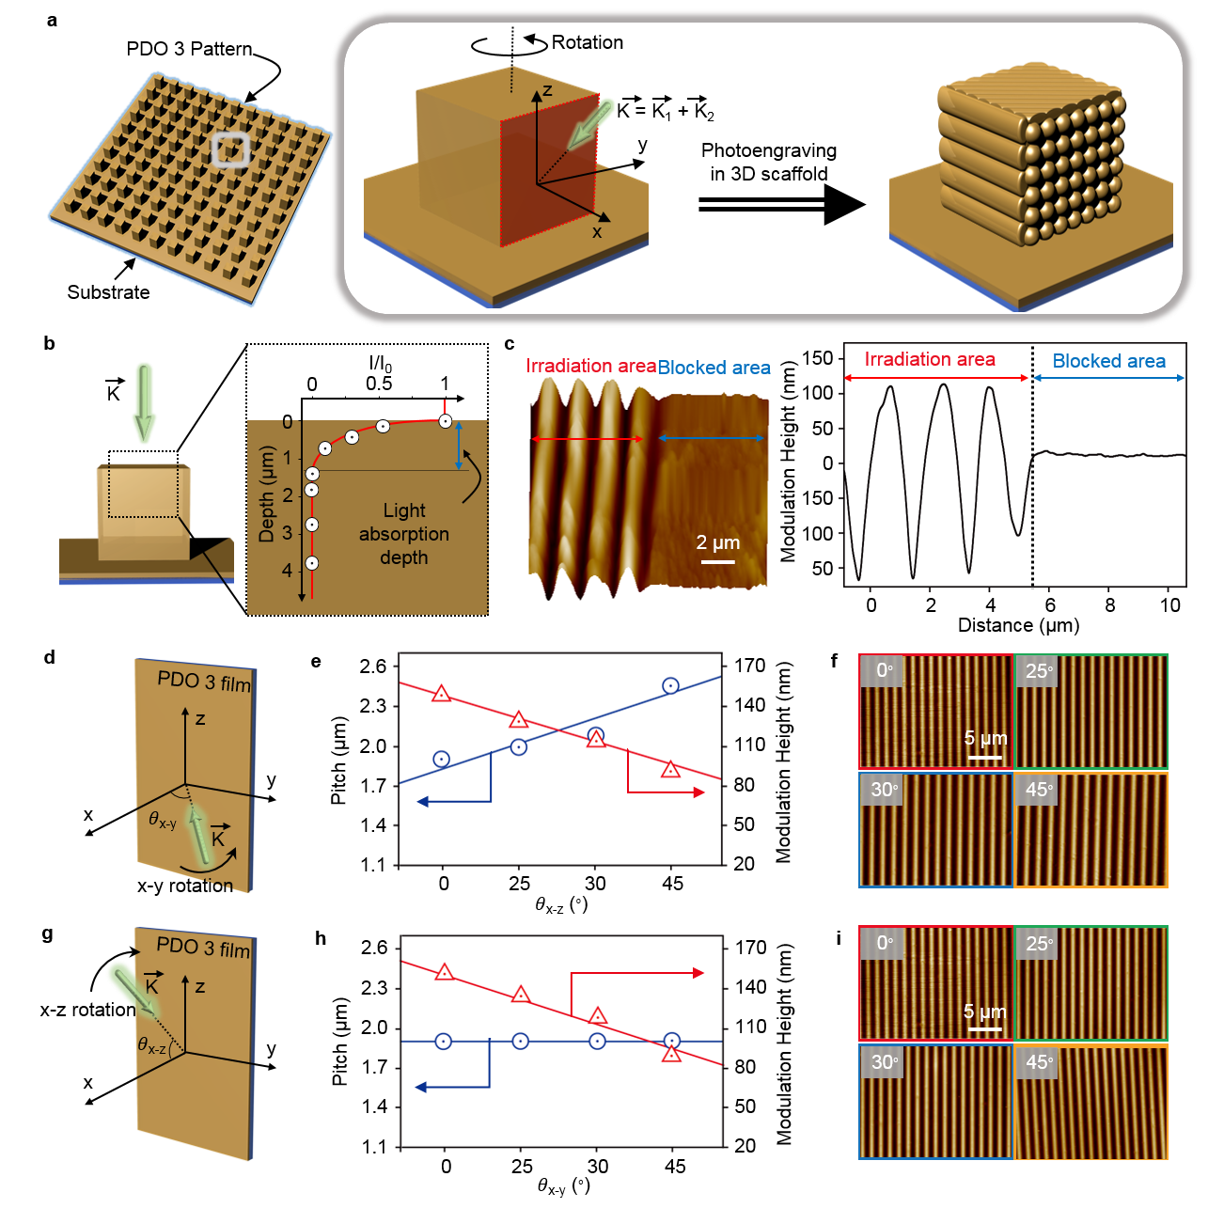

**Figure 1** (a) A schematic illustration of the fabrication procedure. (b) Light absorption in the PDO 3 film: light is completely blocked at thickness of 1.3 μm. (c) AFM image and associated height profile at the boundary of a blocked and irradiated region. Independent surface inscriptions of micro-/nanotextures are possible without compromising the structural integrity of the bulk structure. Photoengraving with varying angle of incidence relative to the sample surface normal in the x-y plane (d-f) and x-z plane (g-i), respectively. The modulated pitch and height of the inscribed patterns obtained by exercising control over (d) azimuthal (x-y plane) and (g) polar (x-z plane) tilting of the sample were characterized using an AFM (f and i).

Azobenzene-containing polymers (i.e., azopolymers) are a type of photoresponsive materials that undergo reversible trans- to cis-isomerization upon exposure to light, leading to photofluidization of the polymer chains. Spontaneous formation of surface relief gratings (SRGs), when holographic interference pattern is irradiated, is the most widely explored phenomenon among various photofluidization of azopolymer. This unique phenomenon of SRGs of azopolymers has its origin in the reversible mass-transport-enabled structural evolution, contrary to an irreversible chemical etching or self-assembly of soft building blocks that are commonly used in micro/nanofabrications. By taking advantage of its reversibility in the structural evolution, the directional photofluidization of azopolymer can be actually used to encode special functionality into surface reliefs, for example, periodicity-reprogrammable grating, complexity-controlled grating, and successive overwriting of gratings.[ref]

They have been widely exploited for potential applications, including xxx.24-29 The fabrication of surface relief grating via azobenzene-containing polymers (i.e., azopolymers) has emerged as an important area in micro/nanofabrications.[ref]

While we acknowledge the extant body of published work on the fabrication of micro-/nanostructures with photoengraved SRGs, previous strategies of creating SRGs have been limited to photoengraving of flat surfaces with wave vectors parallel to surface normal.17,18,26,28,29 Usually to make a hierarchical pattern, a microstructured surface is fabricated in the first step and then further processing is carried out to add nano-features over it at the second step by combining different fabrication techniques with different resolutions making a whole process long, complicated and limited to a certain geometrical shape.

Herein, we apply the out-of-plane interference beams to the sides of micropillars made of azopolymers, which we refer as the primary structures, and inscribed the micro-/nanopatterns (*i.e.,* secondary structures), with the possibility of realizing distinct structural features on every facet *i*.*e*., 3D photoengraving (**Figure 1c**). To demonstrate our concept, we fabricated a primary square pillar array, which were fabricated by solvent-assisted soft lithography, with five distinct engraved features on each faceted surface, as elucidated in **Figure 1c**, wherein the direction of interference light, denoted by the wave vector K, is given by the sum of the two incident beam vectors (K1 and K2, shown in **Figure 1b**). This schematic illustration summarizes the major steps of the 3D photoengraving process. The structural description and additional information on fabrication process provided in Experimental Section and **Figure S3**, Supporting Information.

Our central strategy relies on three important characteristics of the light-responsive PDO 3. First, the high light absorptivity of PDO 3. Incident light at 532 nm is completely absorbed by PDO 3 films of thickness < 1.3 μm, which is typically considered as a drawback in photosensitive materials (e.g., SU-8, AZ series, and PMMA photoresists) in optical lithography. Here, it is instead an advantage of in our fabrication strategy.17 (**Figure 1d**) In conventional optical lithographic processes, the inability of light to penetrate deep into the bulk of photoresist films makes it difficult to realize high aspect ratio pillar or deep hole patterns. However, low optical density can be repurposed to open a new avenue to create complex and hierarchical structures. That is, the limited light penetration in a photoresponsive material implies that photoreactions in the polymer can be confined to the surface of a film. As a result, different facets of a 3D azopolymer structure can be selectively inscribed with micro/nanotextures without affecting the bulk of the primary structure, which is important to maintain the integrity of the parent surface-relief.

Secondly, the formed SRG remains confined within the irradiated area and does not compromise non-irradiated regions. To confirm this, we blocked one side of PDO 3 film with a photomask and irradiated the interference light at the boundary of blocked and non-blocked area (see **Figure S4**, Supporting Information). As seen in **Figure 1e**, an SRG is only formed within the irradiated regions with a distinct boundary between blocked and irradiated regions. This is markedly different from other photo- / thermal-sensitive polymers, wherein the propagation of light-/heat induce curing or fluidization with thermal gradients.17,32-34 We believe this is because of the high *T*g of PDO 3, which limits the photofluidization beyond the exposed regions. Therefore, independent inscriptions of micro/nanotextures can be made, selectively, on a target surface.

Lastly, an additional degree of control can be exercised over the photoengraving process by exploiting omnidirectional light irradiation. When azimuthal (*θ*x-y) and polar angles (*θ*x-z) of the interference light (relative to the target surface normal) are varied, which analogously corresponds to sample rotation in the ‘x-y’ plane (**Figure 1f-h**) and ‘x-z’ plane (**Figure 1i-k**) respectively, uniform periodic line patterns are generated. Notably, in the case of pure azimuthal control, the pitch of the periodic line varies directly with *θ*x-y (**Figure 1g**). An observed gradual increase in SRG pitch is the direct consequence of the increase in the pitch of the incident interference beam, effected by the smaller *θ*x-y. Additionally, such an increase in pitch, effected by an appropriate reduction in sample tilt, is accompanied by a gradual decrease in modulated grating height as a result of the attenuation of light reaching the surface of an irradiated (unit) sample area (see **Figure 1f-h**). On the other hand, SRG pitch remains independent of the changes in *θ*x-z due to pitch homogeneity of the incident interference beams in the x-z plane, while the modulated grating height is gradually decreased with increasing *θ*x-z, for the same attenuative reasons mentioned earlier (see **Figure 1i-k**). Explanatory illustrations of these aforementioned dependencies of the modulated sample height and pitch with respect to the interference light directions are presented in **Figure S5,** Supporting Information. Therefore, by controlling the degree of sample tilt in the x-y plane (*θ*x-y) and x-z plane (*θ*x-z) relative to the target surface normal, we can modulate the height and pitch of the resulting SRGs.

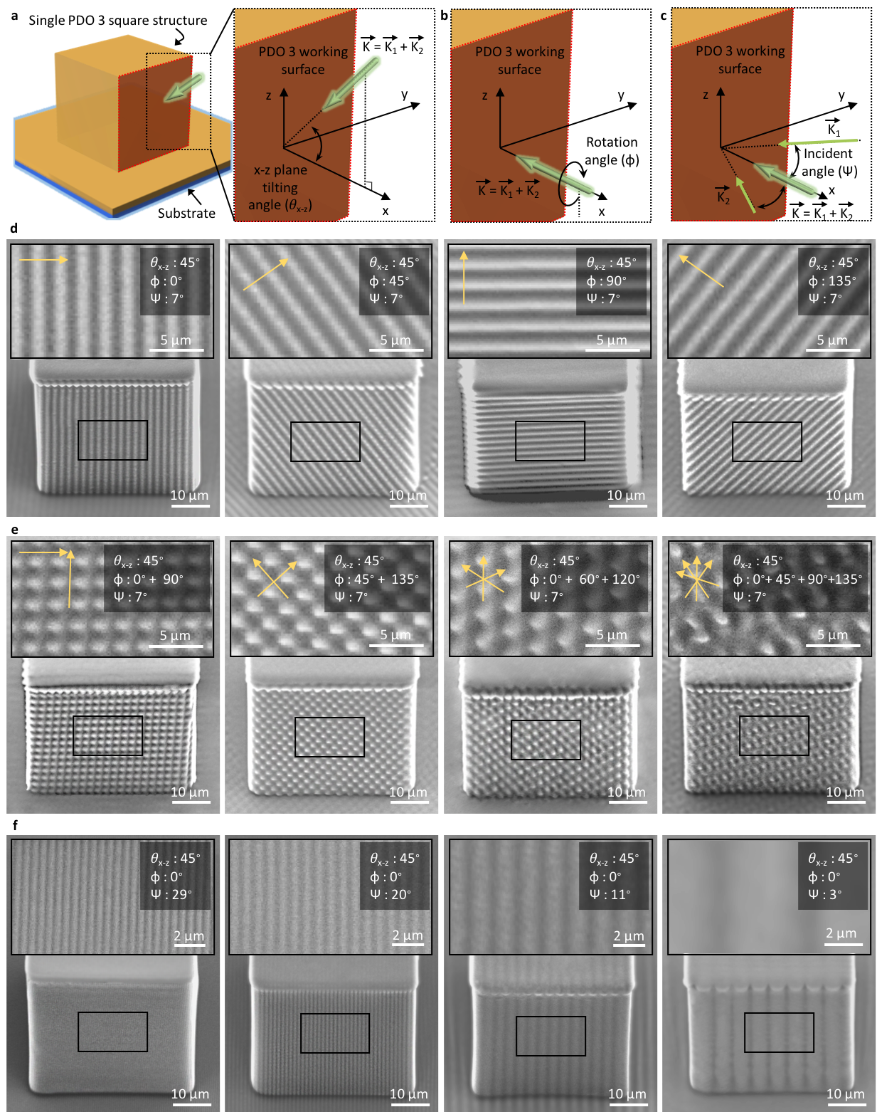

**Figure 2.** Three key parameters for deterministic engraving of diverse SRGs one one side facet of the square pillar. (a) Tilting angle (*θ*x-z), (b) rotation angle (φ), and (c) incident angle (ψ) of the interference beams. A series of SEM images of one side facet of the square pillar after photoengraving by (d) varying the φ from 0°, 45°, 90°, and 135°at the fixed *θ*x-z of 45°and ψ of 7°; (e) superimposing multiple photoengraving process at the fixed *θ*x-z of 45°and ψ of 7°; and (f) tuning ψ of the interference beams from 29°, 20°, 11°, and 3°at the fixed *θ*x-z of 45°and φ of 0°. Insets: magnified view of the secondary pattern and detail irradiation condition. The yellow arrows in (d) and (e) indicate the directions of grating vectors.

To exploit these advantages, we selectively inscribed various micro-/nanotextures on a single facet of the primary PDO3 square pillar array (height of 40 μm and aspect ratio of 1). A library of diverse micro-/nanotextures was successfully engraved on a chosen facet, via a triparametric modulation of polar tilting angle (*θ*x-z) (**Figure 2a**) and rotation angle (φ) (**Figure 2b**) of the interference beam as well as the angle of incidence of the parent beams (ψ  (**Figure 2c**). As mentioned previously, uniform patterns are generated across an irradiated area, for given angles of tilt, in both rotation in the *θ*x-y (**Figure 1f-h**) and *θ*x-z (**Figure 1i-k**). Due to experimental limitations in irradiating a target with interference light while maintaining normal incidence to the work surface, the incident interference beam was tilted at an angle of *θ*x-z of 45° and *θ*x-y of 0° for all the experiments delineated in **Figure 2**.

Interestingly, vectors (or directions) of the inscribed grating patterns can be controlled by varying the rotation angle of the interference beam (φ), as is evidenced in **Figure 2d**. Further, interference line patterns can be superimposed with other 1D analogues to realize increasingly complex architectures. As shown in **Figure 2e**, complex dome structures were successfully engraved on a singly facet of a square PDO 3 pillar, including tetragonally-aligned variants (by mixing two 1D patterns), hexagonally-aligned (by mixing three 1D patterns) and complex periodically-aligned (by mixing four 1D patterns) dome variants.

By exercising control over ψ, the pitch of the engraved pattern can be regulated. In this regard, changing ψ from 29° to 3°, sees the pitch of the engraved line pattern increase from 550 nm to 5.1 µm. These results are predicted by Bragg’s law (d=λ/2nsinψ where d, λ, and n are pitch, wavelength of laser beam, and refractive index of environment, respectively.) within ψ of 29°, 20°, 11°, 7°, and 3° are predicted to give rise to pattern pitches of 548 nm, 777 nm, 1.39 μm, 2.18 μm, and 5.08 μm, respectively *i*.*e*., higher angles of incidence can be expected to give rise to patterns of larger pitch. These results speak to the flexibility of our proposed technique in tuning the shape and features of secondary small-scale patterns, simply and with relative ease. Further, the above systematic study delineates the various degrees of control that can be exerted over the micro-/nanotexturing process (orientation, overall dimensions, complexity and periodicity) to inscribed precisely-controlled structural features onto any desired facet of a work surface.

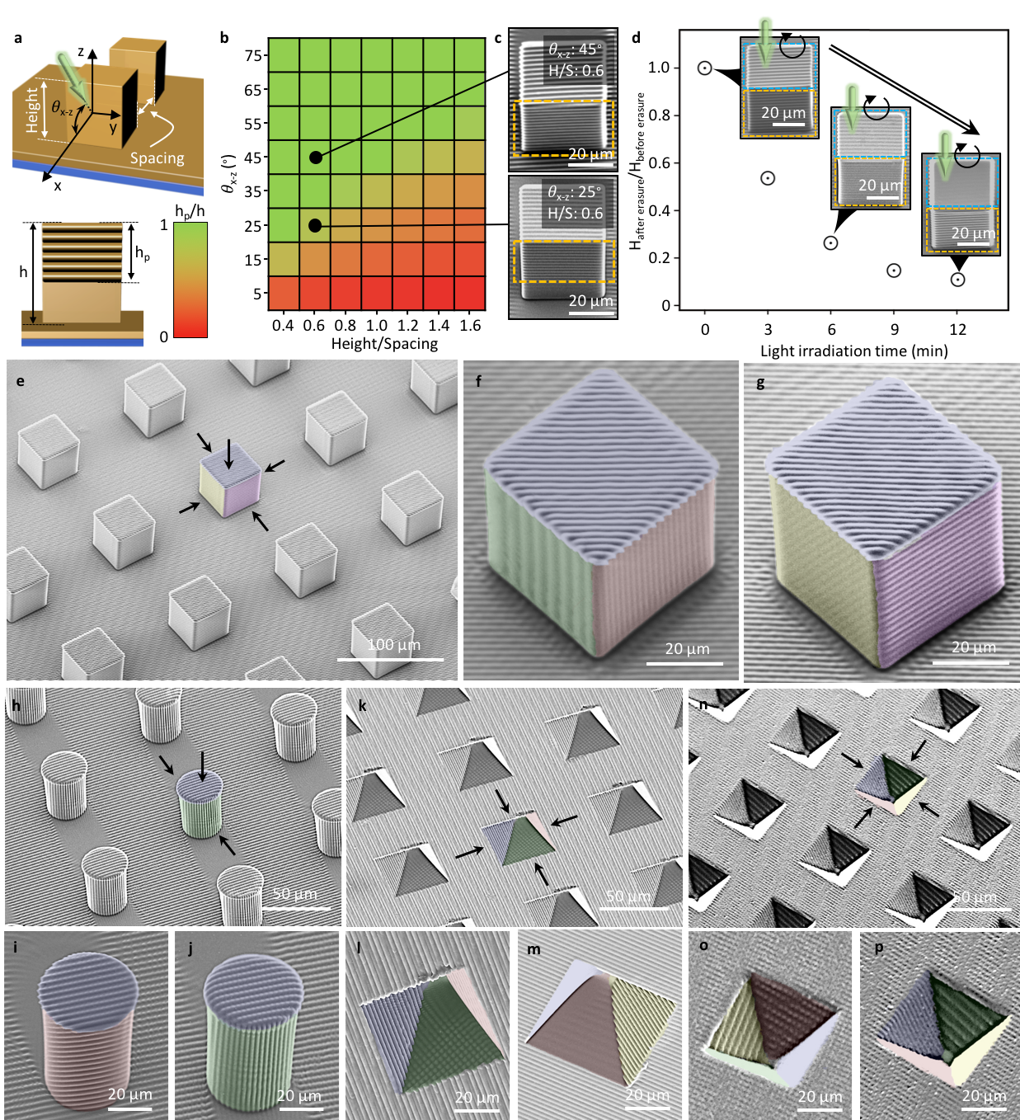

**Figure 3.** Fabrication of hierarchical structure arrays by the3D photoengraving process. (a) Schematic illustrations of the azimuthal angle (θx-z), height, and space for the primary square pillar array. The heights of the primary square pillar and the secondary structures are marked by ‘h’ and ‘hp’, respectively. (b) Photoengraved structures dependence on the θx-z versus height/spacing ratio and (c) the exemplary SEM images. (d) Erasure of the photoengraved secondary structures by irradiation of one laser beam with circular polarization. Height of the secondary line structures is gradually reduced. (e-p) SEM images of a wide variety of hierarchical structures of different types of the secondary structures with varying grating vectors and dimensionality on different primary structures. (e-g) Primary square pillar array. (h-j) Primary cylinder pillar array. (k-m) Primary pyramid pillar array. (n-p) Primary inverse pyramid array. For clarity, distinct false colors are overlaid on different surfaces of the primary structures.

The versatility of our photoengraving process in creating arrays of hierarchical structures lies in that large areas of a sample surface can be patterned with a single exposure step and that specific facets of a target 3D structure can be selective engraved as described earlier. Further, by extension, with sequential exposure steps, inscriptions of different patterns can be made on every facet. However, as the local photoengraving process is critically influenced by neighboring structure geometry, the relationship between the azimuthal angle (*θ*x-z) of interference light and the ratio of height/spacing of the primary structure array is important. This can be seen in **Figure S6**, Supporting Information, which shows how the results of the photoengraving process on square primary structures can be predicted, by comparing the degree of sample tilt with a critical value of *θ*x-z given by,

$θ_{x-z}^{critical}= \tan^{-1}\left(\frac{height}{spacing}\right)$ (1)

This is the minimum value of sample tilt that ensures the completely engraving of any given side wall of a patterned primary structure with existing secondary structures (**Figure S6a**). When *θ*x-z > (**Figure S6b**), interference light reaches the entirety of the selected target facet of the primary square pattern, thereby ensuring its complete inscription. On the contrary, when *θ*x-z < (**Figure S6c**), regions of targeted facets lie in the shadow of proximal structures in the foreground, thereby shielding them from irradiation and inscription.

This dependence on the tilting angle and the geometric parameters of the parent structure *i*.*e*., ratio of height to spacing, is delineated in **Figure 3a-b**. SEM images of two samples are presented in **Figure 3c**, with the same height-spacing ratio of 0.6 and that were irradiated with the same interference beam (φ = 90° and ψ = 7°), yet at different sample tilting angles, *θ*x-z of 45° and 25°, respectively. In the case of *θ*x-z = 45°, the entire targeted facet (height/spacing = 0.6) was inscribed with a secondary pattern whereas with *θ*x-z = 25°, only a partial inscription of the targeted surface was observed. Therefore, as shown in **Figure S7**, Supporting Information, by selecting target-appropriate photoengraving conditions, truly selective and on-demand inscription of a large target surface area can be realized, while ensuring complete coverage.

It must be noted that the process of irradiating a sample with interference light at any given value of sample tilt in the x-z plane (0°<*θ*x-z≤90°), unavoidably results in the (at times, unwanted) irradiation and inscription of the top surfaces of a primary structure (see **Figures 3c** and S5). Interestingly, because the photoisomerization of azobenzene molecules are reversible, our method also allows for the erasure of undesired photoengraved patterns via follow-up irradiation with a single, circularly-polarized beam of light. A circular polarized beam radially fluidizes the initially solid azopolymer (isotropic fluid motion) and consequently, this radially-fluidic motion combined with the fluid’s inherent tendency to minimize surface energy, drives the near-perfect erasure of photoengraved secondary structures.17 As can be seen in **Figure 3d**, the irradiation of circularly polarized light normal to the surface sees the engraved secondary structures gradually erased with increasing irradiation time. With normal incidence, erasure only occurs on the top surfaces of the primary target structures with secondary patterns on the side walls remaining unaffected. From these results of the systematic study described above, we conclude that the photoengraving process can be used to obtain precisely controlled structural features (e.g., dimension, modulation height, and periodicity) on any desired facet of a primary structure by selecting appropriate sequences of inscription and erasure steps. **Figure S7**, Supporting Information, provides an example of the large areal, selective inscription of a secondary structure on a chosen side facet of a square pillar array (primary structure) using our photoengraving method.

By going a step further and extending this process to selectively engrave every facet of a primary microstructure, it is possible to integrate different micro-/nanotextures with different grating vectors and dimensionality, into a single, composite, textured surface. Specifically, in contrast to irreversible chemical etching or self-assembly approaches, the unique possibility for erasure, enables a stepwise photoengraving process to be performed (*e*.*g*., inscription/erasure/inscription), to ensure the truly-deterministic engraving and integration of heterogenous micro/nanotextures on different facets of a single, multifaceted primary structure. The results of such a process is demonstrated in **Figures 3 e-g** wherein a combinatorial set of inscription/erasure steps sees diverse secondary structures inscribed on different facets of a primary square pillar array. **Figure S8** summarizes the sequence of steps (including values of φ, ψ, and *θ*x-z at each steps) involved in this micro/nanotexturing strategy; inscription and erasure were herein achieved with an interference light beam and a single, circularly polarized beam, respectively.

This technique is not limited to square pillar arrays. As seen in **Figures 3h-p**, a wide variety of primary structures, including cylindrical pillars (**Figures 3h-j**), pyramids (**Figures 3k-m**) and inverse pyramid (**Figures 3n-p**), fabricated by soft lithography (**Figure S3**, Supporting Information), can be inscribed with diverse, secondary structures. A systematic study of the relation between *θ*x-z and the height to space ratio for these various aforementioned primary structure arrays, is presented in **Figure S9**, Supporting Information. The **Figure S10**, Supporting Information, summarizes the sequences and their corresponding light irradiation condition (values of φ, ψ, and *θ*x-z) of photoengraving process for the fabrication of secondary structures on cylindrical pillars (**Figures 3h-j**), pyramids (**Figures 3k-m**) and inverse-pyramid (**Figures 3n-p**) primary structures.

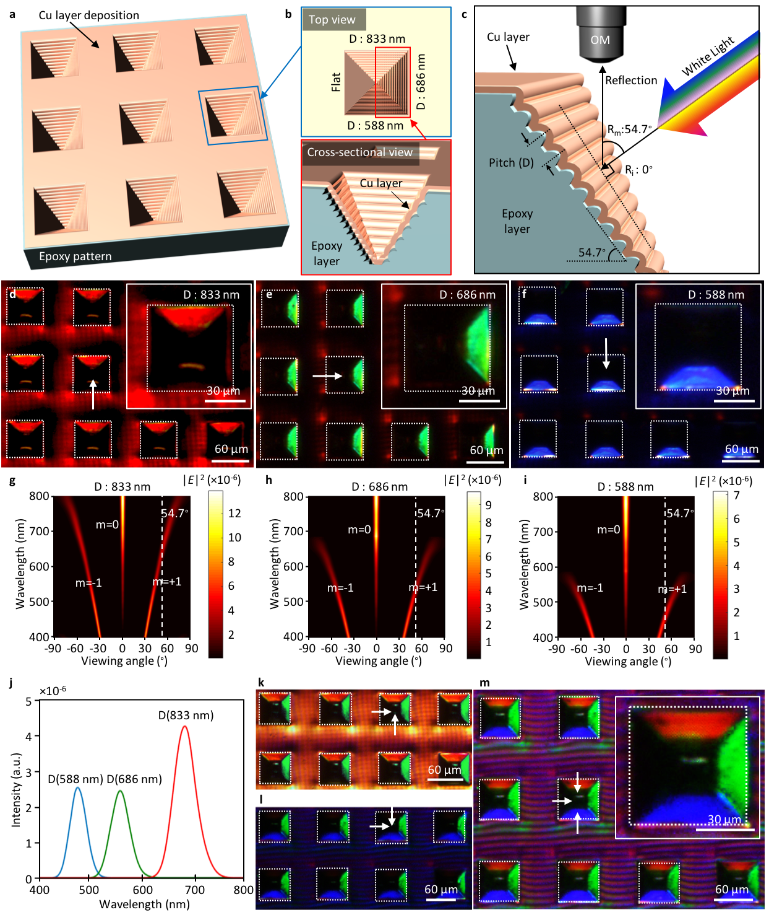

**Figure 4.** A multiplexing, structure-color reflection filter that integrates three different pixelated diffraction colors into each individual pyramidal structure unit. (a-b) A schematic illustration of the structure-color filter. All grating vectors are normal to the surface, but grating pitch on the three engraved facets are different, 588 nm, 686 nm, and 833 nm. (c) The optical setup to observe the reflected colors. (d-f) Optical microscope (OM) images of the structure colors generated under an oblique, white light illumination. (d) Red color reflected from the gratings with a pitch of 833 nm, (e) green color from the gratings with a pitch of 686 nm, and (f) blue color from the gratings with a pitch of 588 nm. The white arrows in (d-f) indicate the direction of white light illumination. Inset: high magnification OM images. (g-j) The FDTD calculation of the wavelengths reflected upon varying the viewing angle. The white dashed line refers to the spectra observed at a 54.7 degree viewing angle as shown in (b). (k-m) The illuminated multiplexing reflected structure-color filter: OM images of (k) red and green; (l) green and blue; (m) red, green, and blue colors generated by illuminating the filter with multiple white light beams. The white arrows in (k-m) indicate the direction of white light illumination. Inset: high magnification OM images.

We applied our 3D photoengraving system to develop a multiplexing structure-color filter via distinct secondary line patterns inscribed on each facet of inverse pyramidal arrays. A number of interesting studies to develop reflection-mode color filters have been carried out thus far,17,35-37 that have offered several advantages over conventional pigment-based color filters in terms of robustness and reliability, compatibility, and reduced chemical hazardousness. However, realizing the integration of diverse and discrete structural colors into a single composite has proved challenging, requiring a complex and sophisticated structural fabrication system.16,38,39 However, it is possible using 3D photoengraving system reported here. To demonstrate this, we fabricated inverse-pyramidal primary structures and photoengraved secondary, 1D line patterns on three different facets, with grating vectors orthogonal to the substrate and with different pitch on each inscribed facet (i.e., 588 nm, 686 nm, and 833 nm, respectively). This was followed by the transformation of UV curable epoxy materials and the deposition of a 10 nm thick layer of copper on every surface, as shown in **Figure 4a-b**. The primary inverse-pyramid structures measure 60 µm wide on each side and 42.3 µm in depth: the method followed for the fabrication of these primary inverse-pyramidal PDO 3 patterns is described in the Experimental Section. The photoengraving conditions employed were ψ =17.9°, ψ = 22.8° and ψ =26.9° to achieve periodicities of 588 nm, 686 nm, and 833 nm, respectively while φ and *θ*x-z were set at 90° and 35.3° for all associated engraving processes. The detailed engraving process and resulting SEM images are presented in **Figure S11**, Supporting Information. The photoengraved PDO 3 patterns can be transferred to a more thermally- and mechanically-robust, epoxy materials via soft lithographic steps so as to (i) survive the relatively high temperatures of the metal deposition process and (ii) in order to achieve high throughput regarding structure fabrication while avoiding time-consuming laser irradiation step (**Figure S12**, Supporting Information). Due to the comparatively lower surface energy of PDO 3,17 the hierarchical structures obtained upon photoengraving, can be replicated with polydimethylsiloxane (PDMS) stamps with high structural fidelity. The latter can be used to transfer complex hierarchical photoengraved structures in a single step to a more robust, UV-curable epoxy material followed by the subsequent deposition of the metal layer as shown in **Figure S12**, Supporting Information.

Upon illuminating the engraved specimen with oblique white lights, we observed clear and vivid structure colors at each facets of primary inverse-pyramid, which we referred to it as multiplexing color filter. The optical setup for the observation of reflective color generation is presented in **Figure 4c**. An incident angle of 54.7° permits normal incidence of white light on the sloped facets of the pyramidal arrays on the target surface and converts the same into vertical radiation by grating-enabled diffraction. The resulting reflective colors obtained as a consequence of the different grating periodicity on each facet in every inverse-pyramidal pixel are shown in **Figure 4d-f**. Clear and vivid colors of red, green, and blue were generated with grating periodicities of 833 nm, 686 nm, and 588 nm, respectively. To elucidate the color generation from our specimen, we performed finite-difference time-domain (FDTD) simulations as shown in Figure 4g-j and Figure S13, Supporting Information. The simulated results of color reflected with respect to viewing angle and wavelength for different grating periodicities (i.e., 588 nm, 686 nm, and 833 nm) are presented in Figure 4g-i. It can be seen that only 0th and ±1st diffraction orders are present, which is consistent with results from grating equations. The white dashed lines refer to the spectra observed at a viewing angle of 54.7°, and the observed color depends entirely on the 1st diffraction order at this viewing angle. Figure 4j summarizes the simulated reflection spectra of the secondary line patterns with different grating periodicities (i.e., 588 nm, 686 nm, and 833 nm) under white light illumination at 54.7° viewing angle, and red, green, blue peaks are observed in gratings with 833 nm, 686 nm and 588 nm period, respectively. The geometry for the simulation as shown in Figure S13, Supporting Information, is based on the AFM profiles of each faceted surface which was already shown in Figure S11b, Supporting Information.

As shown experimentally and verified by simulation results, our structure generates vivid colors in the visible spectrum and with distinct reflective peaks that are highly desirable for structure-color applications. Interestingly, these vivid reflected colors as shown in **Figure 4d-f** can be integrated into a single composite when illuminated with multiple white light sources. By illuminating the sample with two white light beams, two different reflective colors, e.g., red and green (**Figure 4k**) or green and blue (**Figure 4m**), were clearly generated at distinct facets of the primary inverse pyramid. With three white beams incident on the three inscribed facets of the inverse-pyramid structure, vivid red, blue, and green are simultaneously observed, as shown in **Figure 4m** which indicates that each inverse pyramid can serve as a single pixel in a display. For real display applications, black is also highly desirable for the sake of contrast. As shown in **Figure 4m**, a black colored area can be incorporated in the pixel by taking advantage of a flat unpatterned facet of the parent truncated inverse pyramid structure (**Figure 4b** and **Figure S11b**, Supporting Information). The perception of a black colored surface is due to the fact that only a fraction of the white incident light, responsible for the generation of structure color upon reflection from the sloped, inscribed facets shown in **Figure 4**, are reflected by the flat bottom facet for the entire visible wavelength region i.e., less than 10 % is converted into vertical radiation. The relative absence of light i.e., low light intensity in the reflected plane, engenders the perception of a relatively black area.

**CONCLUSION**

We have developed a new strategy for the creation of complex hierarchical architectures via 3D controlled, photoengraving of azopolymers. Our method allows for the fabrication of micro- and nanoscale patterns on diverse 3D scaffolds in an independent and on-demand fashion with high throughput by exerting systematic control over the photoengraving process. Key to our approach are the following properties of azopolymers: i) their limited light absorption in the direction of the film’s thickness, ii) independent photoengraving of different small-scale patterns without compromising the structural integrity of primary structure, and iii) capable of photoengraving process even under condition of omni-directional interference light irradiation. We applied our 3D photoengraving technique to create a multiplexing structure-color filter by integrating distinct nanoscale gratings on each facet of an inverse pyramidal array. The results prove our newly developed fabrication technique has promise for various fields and in particular, for applied photonics.

**Experimental Section**

***Synthesis of poly(disperse orange 3) (PDO 3)*.** PDO 3 was polymerized from disperse orange 3 (5.8 mmol, Sigma-Aldrich) and bisphenol A diglycidyl ether (5.8 mmol, Sigma-Aldrich) at 110 °C for 48 h. After the reaction, the PDO 3 was fully dissolved in tetrahydrofuran (THF, Sigma-Aldrich), and precipitated via the dropwise addition of methanol. After filtration, the obtained PDO 3 was dried in a vacuum oven at 100°C for 3 days to completely remove the solvent and then stored in a nitrogen-purged desiccator. The weight-average molecular weight (Mw) of the obtained PDO 3 was measured by a Gel Permeation Chromatograph (GPC; Water e2695) as 9702 g/mol using THF as an eluent with an injection volume of 100 µL and flow rate of 0.6 mL/min at room temperature. The glass transition temperature (Tg) was measured as 118.7 °C using NETZSCH DSC 214 (Polyma) at a heating rate of 10 ºC/min in N2.

***Preparation of the primary PDO 3 structures***. The primary PDO 3 pattern was prepared by the solvent-assisted soft lithographic technique seen in Figure S3. The synthesized PDO 3 was dissolved in N-methyl-2-pyrolidone (NMP, Sigma-Aldrich) to obtain a 30 wt% solution. The PDO 3 solution is then carefully dropped onto the substrate (e.g., glass). The glass substrates were rinsed before use with deionized water, acetone, and ethanol, in order. A patterned PDMS mold was then placed onto the PDO 3 solution. Once NMP was completely evaporated (at 45 °C for 12h), a uniformly replicated PDO 3 primary structure was generated, as shown in Figure S3.

***Interference Light Irradiation Setup*.** A photograph of the interference patterning setup (Coherent Verdi V6, wavelength of 532 nm, max output power of 6W) for photoengraving is shown in Figure 1b. The interference light was formed by combining two orthogonally circular (OC) mode laser beams (*i.e.,* interference of right-handed and left-handed circularly polarized beams). Generally, the OC mode is more efficient to form SRG in an azopolymer film when compared to other combinations of the interference beams such as the s-:s- mode or +45:-45 mode. The intensity and polarization of the beams were controlled using a neutral density (ND) filter (Thorlabs, Inc) and half/quarter waveplates, respectively. The total light intensity of the laser light source was 30 mW/cm2 (the intensity of each beam was 15 mW/cm2). We used a spatial filter (Thorlabs, Inc) to enlarge the laser beam from 3.3 mm in diameter to several cm in diameter and added an iris to precisely control the light irradiation area (Figure 1a-b). In this study, the exposed area was 2 cm in diameter. The irradiation time was precisely tuned using an electronic shutter.

***Preparation of PDO 3 Inverse Pyramid Structures*.** The Si wafer (prime grade of <100> orientation, P type, B doped with a resistivity of 1-10 ohm/cm) was first coated with ~100 nm of LPCVD SiN as an etch mask. The masking layer was patterned using standard lithography, followed by the STS RIE (reactive ion etching). The patterned wafer was wet etched in 32 wt (?)% KOH solution for 60 mins to obtain the inverse pyramidal structures. The remaining resist was stripped using the Branson barrel etcher. The inverse pyramidal structures on Si wafer was used a master and replicated into PDMS. The PDO 3 primary inverse pyramid structure was obtained by imprint lithography as shown in Figure S3.

***Optical Simulation***. FDTD simulation is conducted using Lumerical’s FDTD Solutions. 1D metallic SRGs (10 nm Cu onto Epoxy, see structural geometry in Figure 4) with periodicity of 833 nm, 686 nm, and 588 nm, respectively, and modulation height of 150 nm were used, and the sinusoidal modulation profile was taken from experimental measurement by AFM (Figure S11 i-iii). For all calculations, the complex permittivity of Cu was retrieved from Palik model and the refractive index of epoxy was obtained by using ellipsometry (J.A. Woollam V-VASE). Simulation was performed in 2D, and periodic boundary conditions and symmetry were used for one unit cell of the sinusoidal grating for efficient use of computer memory. Absorbing boundary conditions were imposed on the other two boundaries in the light illumination directions. The grating structure was meshed to 1 nm resolution for accurate calculations. Visible light wavelength from 400 nm to 800 nm was used in light source. The same grating geometry was simulated both in transverse-electric (TE) and transverse-magnetic (TM) polarization states. The results from TE and TM polarizations were averaged to get unpolarized results to mimic the white natural light illumination. Results under unpolarized illumination are reported in this paper. The reflection spectra were collected and far-field calculations were performed using the far field function in FDTD software to extract the final reflection spectra with respect to viewing angles, as shown in Figure 4 g-i.

***Characterization*.** All the structures were imaged with scanning electron microscopy (SEM, FEI Quanta 600) at 10 keV, optical microscopy (Olympus, BX 61), atomic forced microscopy (AFM, Bruker ICON), and a digital camera (Canon, EOS 100D), respectively. For SEM imaging, the samples were sputter coated with a 10 Å platinum film. The multiplexing reflected structure-color shown in Figure 4 was imaged using an optical microscopy (Olympus, BX 61).

**ACKNOWLEDGMENTS**

This research was supported by

**AUTHOR CONTRIBUTIONS**

All authors approved the manuscript.

**ADDITIONAL INFORMATION**

Supporting information is available in the online version of the paper. Correspondence and requests for materials should be addressed to Prof. Shu Yang.

**COMPETING FINANCIAL INTERESTS**

The authors declare no competing financial interests.

**Supporting Information**

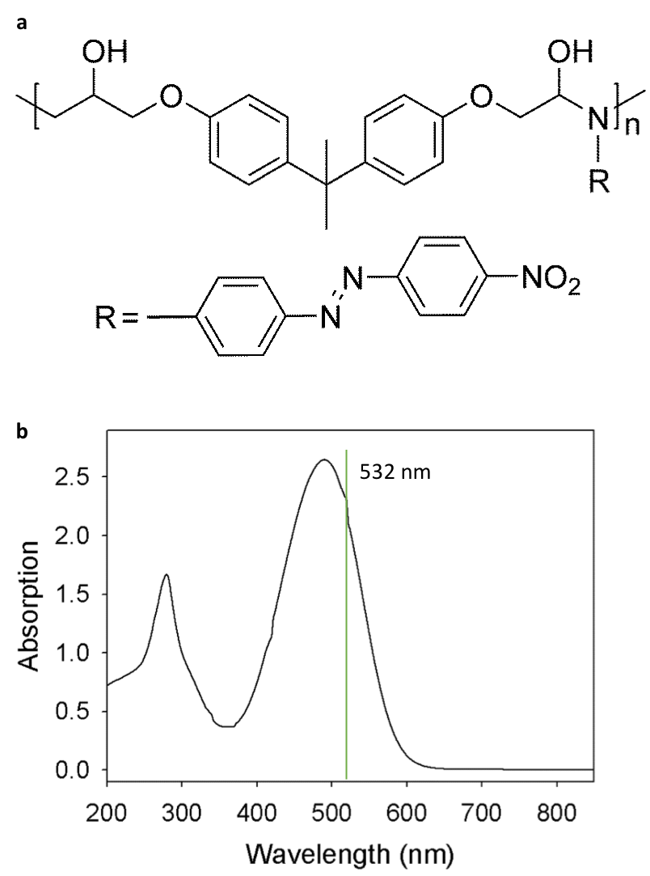

**Figure S1.** (a) The chemical structure of PDO 3, consisting of a polymeric host impregnated with azobenzene molecules. (b) UV-vis absorption spectrum of PDO 3. Laser beams of wavelength ~ 532 nm were used in our experiments as PDO 3 has strong absorption in this regime.

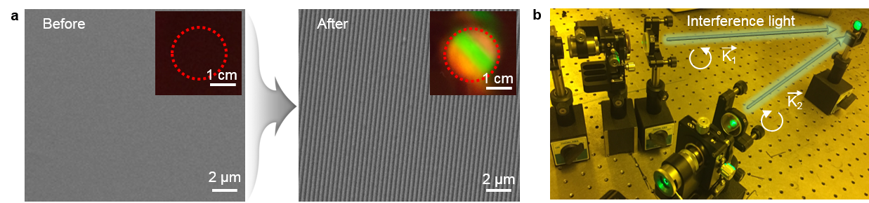

**Figure S2.** SRGs via . (a) SEM images of the azopolymer (PDO 3) surface before and after photoengraving of line patterns. Inset: macroscale optical images of the pristine and photoengraved PDO 3 surfaces. Iridescent color over a large area (diameter ~ 2 cm) is observed after irradiation of light. (b) Photo of the optical setup to generate interference light from two orthogonally-rotated, circular polarized, coherent laser beams. The white arrows indicate the direction of polarization.

When a thin film (here, PDO 3 film) is irradiated by two interference laser beams that are orthogonally-rotated and circular polarized, periodic SRGs form spontaneously as shown in **Figure 1a-b**, at temperatures well-below the glass transition (*T*g) temperature (*i.e.,* 120 °C), and thus the resulting surface patterns are highly stable at room temperature.30-32 For example, Here, the incident angle, intensity and irradiation time were set to be 7°, 30 mW/cm2, and 10 min respectively, Insets in **Figure 1a** are macroscale optical images of the PDO 3 film, before and after irradiation. iridescent colors is uniformly formed over a centimeter area (diameter ~2 cm) and can be enlarged.

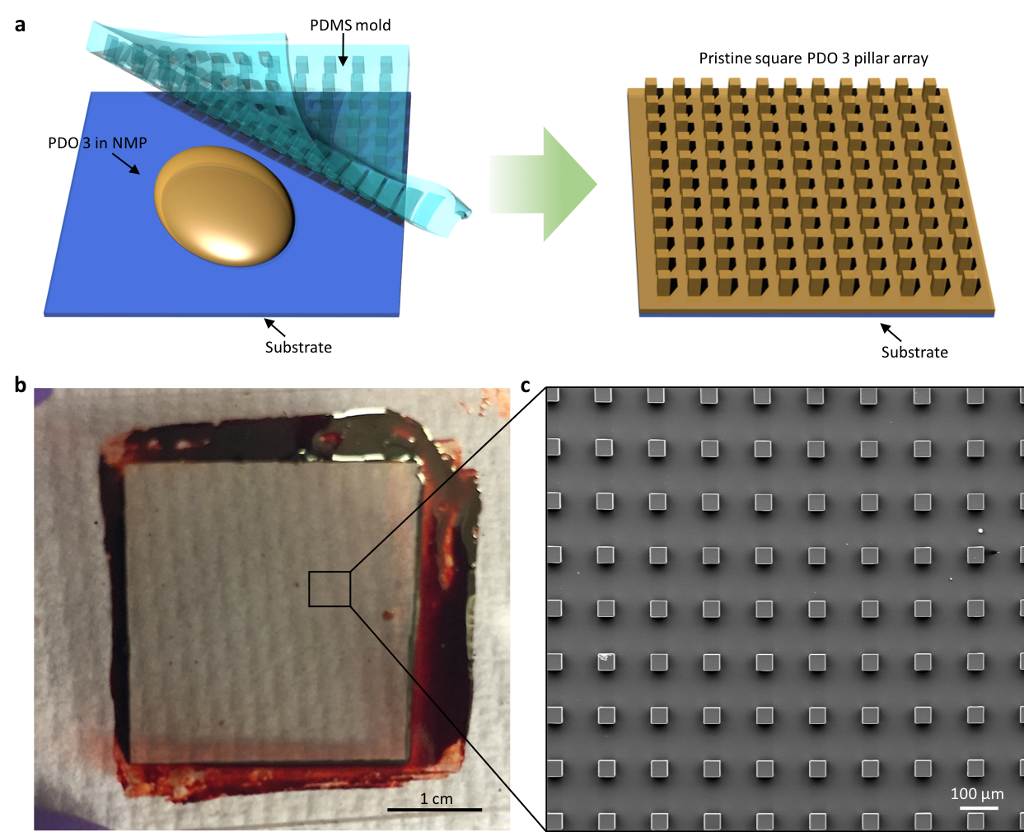

**Figure S3.** (a) A schematic illustration of the solvent-assisted, soft lithographic technique used to fabricate square azopolymeric pillar arrays. (b) An optical image and (c) SEM micrograph of the resulting azopolymeric pillar arrays fabricated on a glass slide.

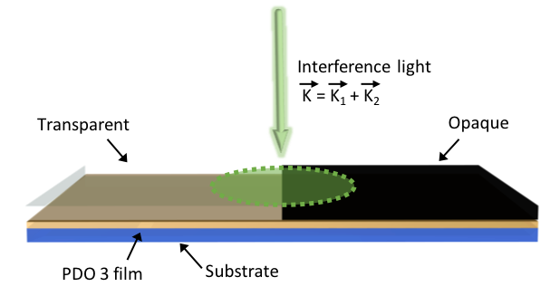

**Figure S4.** A schematic illustration of the experiment to demonstrate deterministic / independent inscription. A region of the PDO 3 film is blocked with a photomask and the sample is irradiated with an interference light beam directed at the boundary of a blocked and non-blocked area.

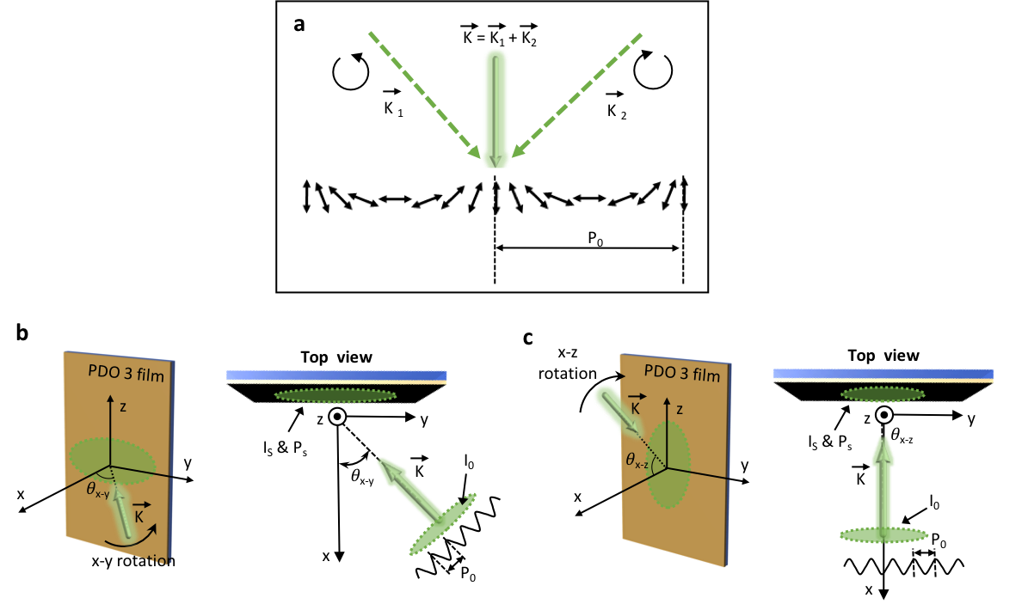

**Figure S5.** (a) A schematic depicting the spatial polarization distribution of the incident interference beam formed by superimposing orthogonally-rotated, circular polarized, coherent laser beams. The direction of the incident interference beam (K-vector) is given by the sum of the parent beam vectors, K1 and K2. The pitch of the resulting interference light is given by P0. Schematic illustrations (side and top views) depicting photoengraving while tilting the incident light beam vector relative to the sample normal (or vice-versa) in the (b) x-y plane and (c) x-z plane respectively.

In Figure S5b-c, light intensity per unit area and the pitch of the interference beam are denoted by I0 and P0, respectively, and the incident light intensity per unit area and pitch of the induced surface pattern (*i*.*e*., SRG pitch) in the PDO 3 film are given by Is and Ps, respectively. In Figure S5b (tilting in the x-y plane), Is and Ps are calculated according to

$I_{s}=I_{0}\cos{θ_{x-y} ,(0≤θ_{x-y}<90 )}$ (1)

$P_{s}=P_{0}/\cos{θ_{x-y} ,(0≤θ_{x-y}<90 )}$ (2)

Therefore, for a given increase in $θ_{x-y}$, pattern heights gradually decrease due to an effective attenuation of light intensity reaching the surface of the PDO 3 film; increasing x-y tilt sees a simultaneous increase in the pitch of inscribed patterns. In Figure S5c (tilting in the x-z plane), Is and Ps are calculated as below

$I_{s}=I_{0}\cos{θ_{x-z} ,(0≤θ_{x-z}<90 )}$ (3)

$P_{s}=P_{0}$ (4)

Accordingly, for a given increase in $θ_{x-z}$, pattern heights decrease in the similar fashion due to light attenuation. However, pattern pitch remains unaffected in this case.

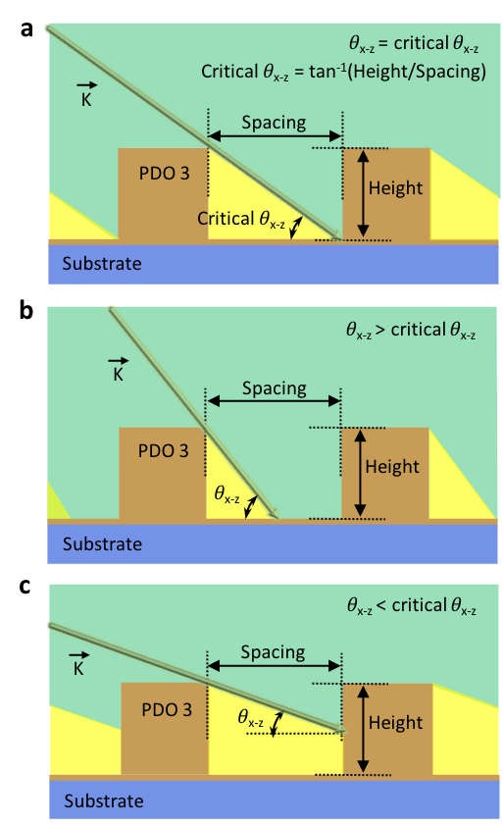

**Figure S6.** The relationship between the azimuthal angle (*θ*x-z) of interference light and the ratio of height/spacing of the primary square structure array: (a) *θ*x-z = critical *θ*x-z, (b) *θ*x-z > critical *θ*x-z, and (c) *θ*x-z < critical *θ*x-z.

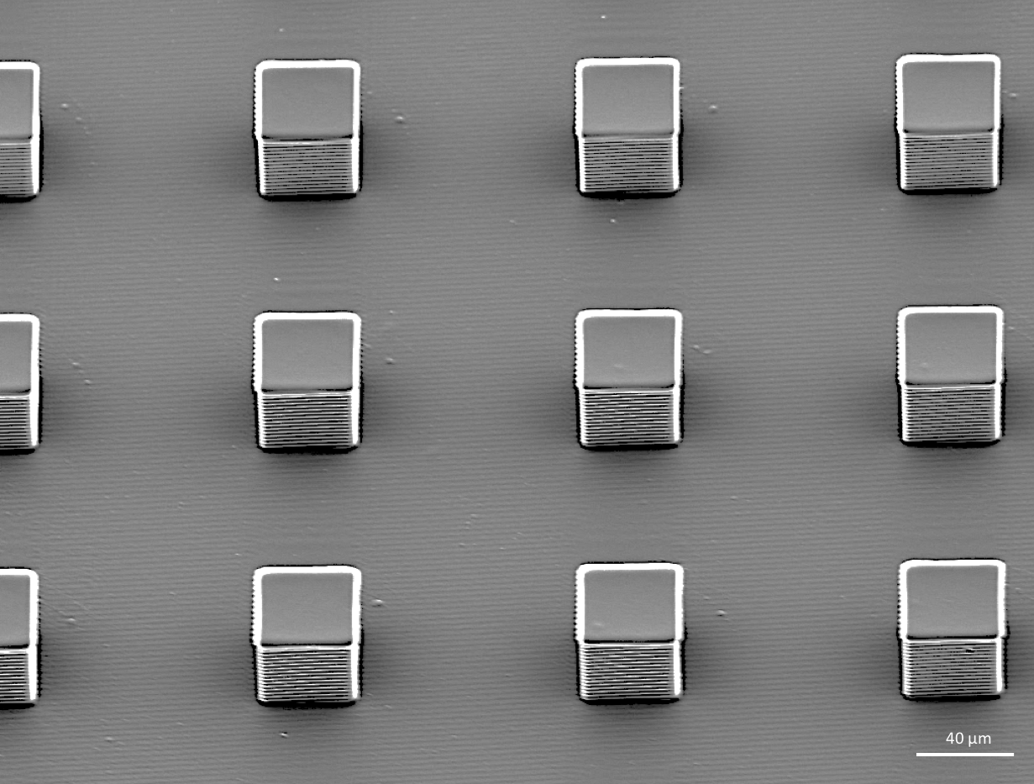

**Figure S7.** SEM image of an example showing selective inscription of a secondary structure only on a selected side facet (here, facing the front) of a square pillar array (the primary structure) with our photoengraving method.

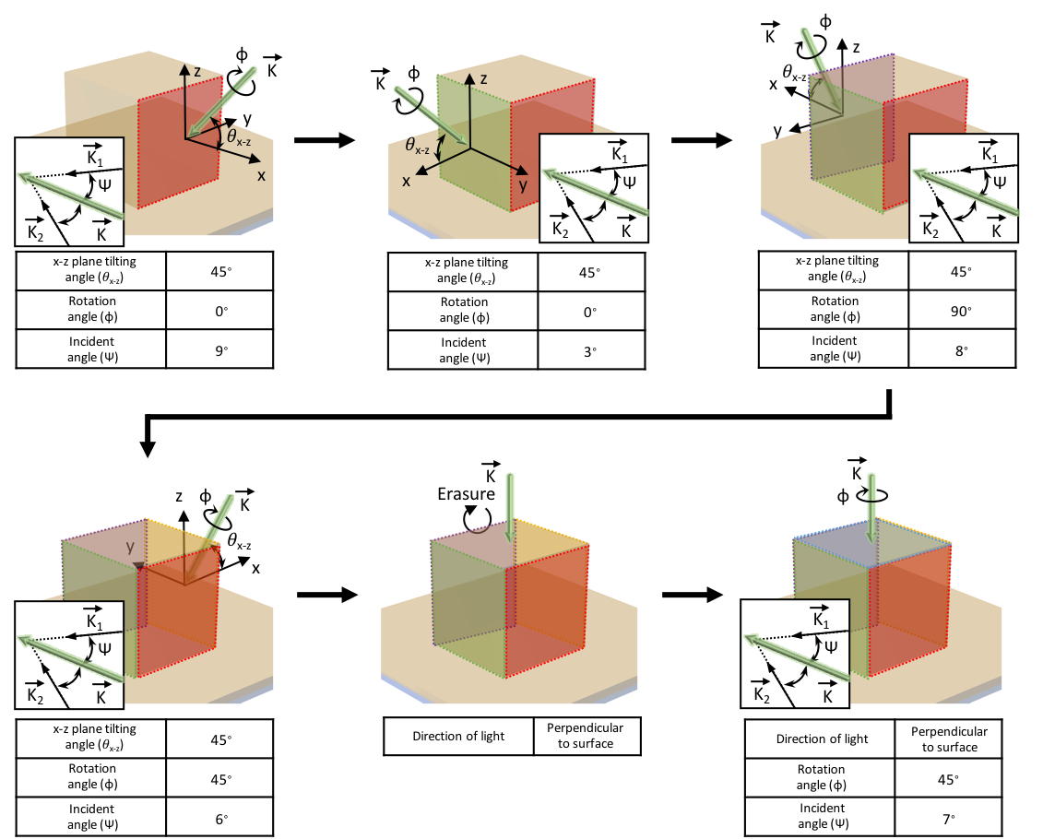

**Figure S8.** The sequence of steps in photoengraving the secondary micro-/nanotextures on a square primary structure; photoengraving and erasure were herein achieved with an interference light beam and a single, circularly polarized beam, respectively. Photoengraving conditions for each step of the process, including values of φ, ψ, and *θ*x-z,are tabulated beneath each schematic.

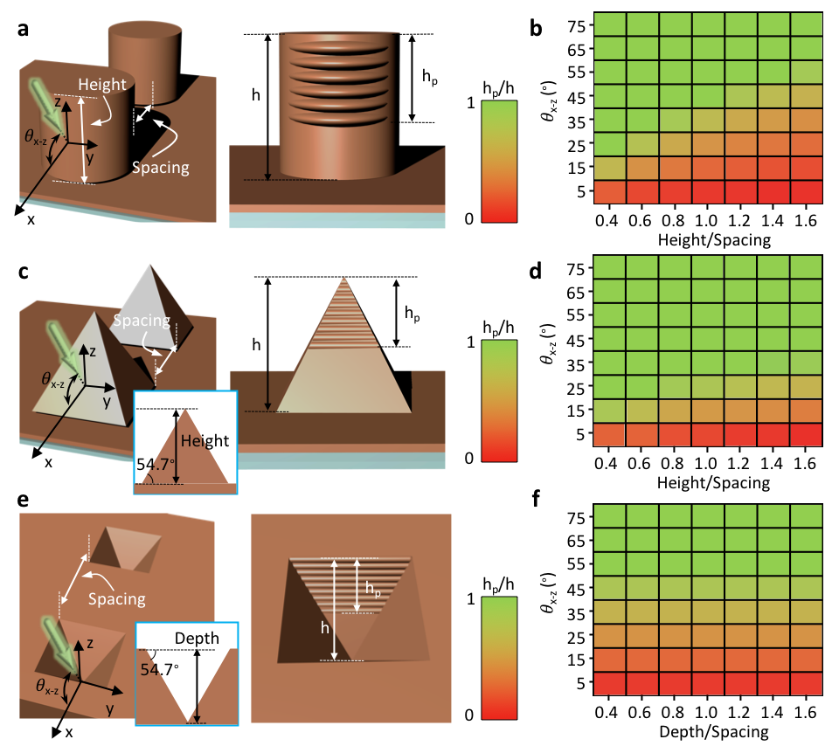

**Figure S9.** Investigation of the relationship between *θ*x-z and the height-to-spacing ratio for various primary structure arrays: (a-b) cylindrical pillars, (c-d) pyramids and (e-f) inverse pyramids.

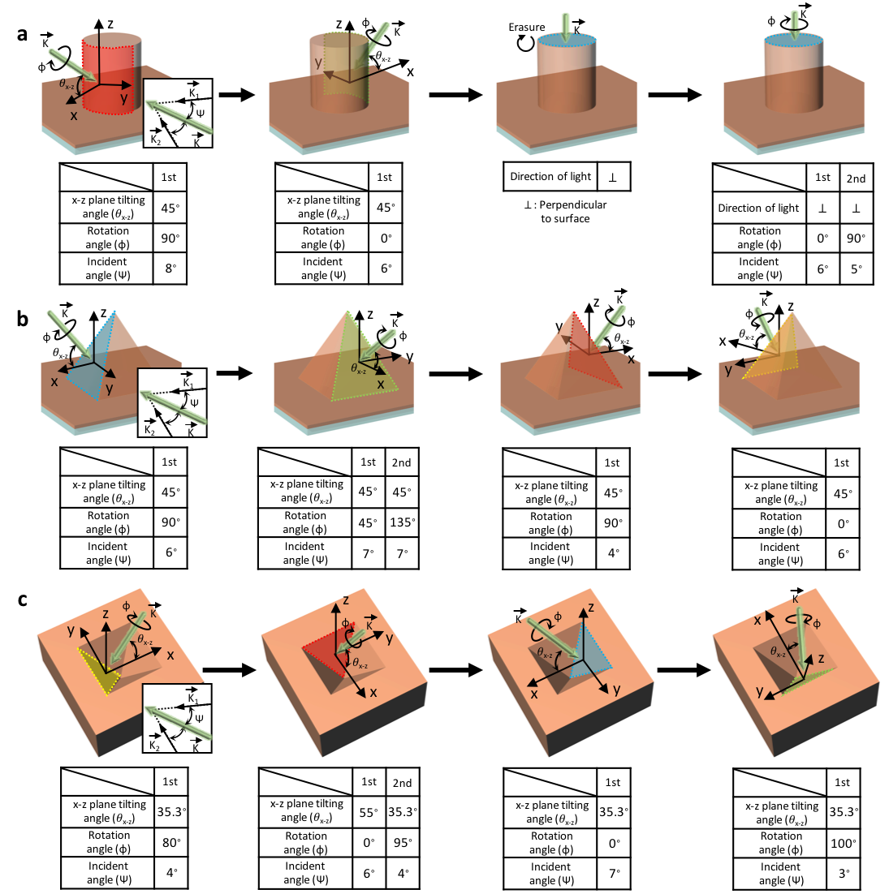

**Figure S10.** The sequence of steps in photoengraving the secondary micro-/nanotextures on various primary structures, including (a) a cylindrical pillar, (b) pyramidal and (c) inverse pyramidal structures. Photoengraving and erasure of the secondary structures are achieved with an interference light beam and a single, circularly polarized beam, respectively. The photoengraving conditions at each step, including values of φ, ψ, and *θ*x-z,are tabulated beneath each schematic.

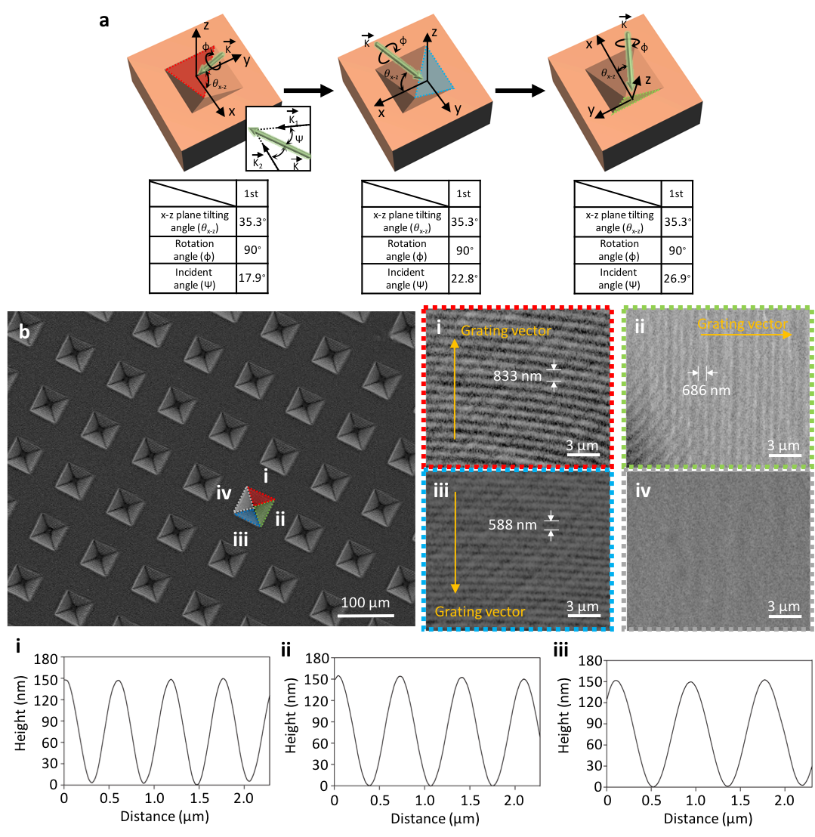

**Figure S11.** 3D photoengraving the inverse pyramidal primary structures to create a multiplexing reflective structure-color filter. (a) Schematics of each step of the photoengraving process (top panel) and their corresponding irradiation conditions (bottom panel) (b) SEM images of resulting structure (top panels) and corresponding height profiles measured with an AFM (bottom panels). The periodicities of the secondary patterns, 1D line gratings, on the three facets of the inverse pyramid are 833 nm, 686 nm, and 588 nm, respectively.

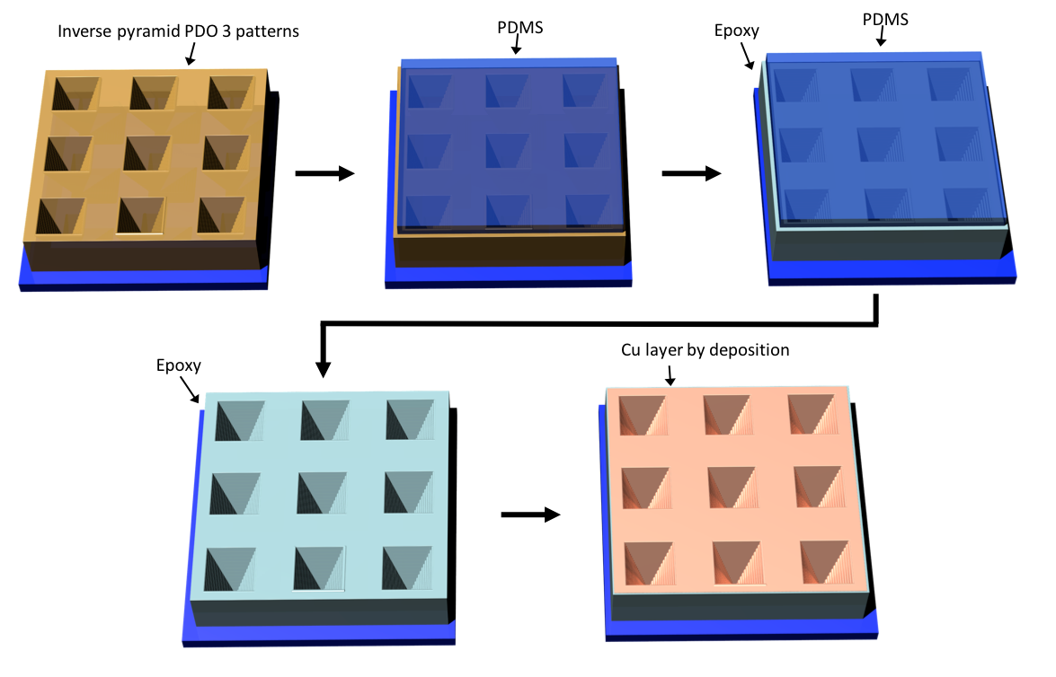

**Figure S12.** Schematic illustrations of transferring the PDO 3 hierarchical photoengraved structures to a UV-curable epoxy via imprint lithography using a PDMS stamp, followed by thermal deposition of 10 nm thick Cu.

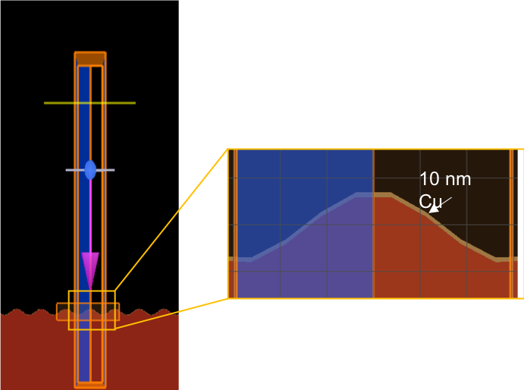

**Figure S13**. A screenshot of a representative FDTD simulation setup with magnified view of the detailed grating structures for 588 nm period gratings with 10 nm conformal Cu coating. The grating base structure is in sinusoidal shape as determined by AFM characterizations. Symmetry is used in the simulation domain for efficient use of computer memory, and is imposed on blue area. The simulated light source wavelength is from 400 nm to 800 nm.

**Reference**

1 Feng, L. *et al.* Super‐hydrophobic surfaces: from natural to artificial. *Advanced materials* **14**, 1857-1860 (2002).

2 Jiang, L., Zhao, Y. & Zhai, J. A lotus‐leaf‐like superhydrophobic surface: a porous microsphere/nanofiber composite film prepared by electrohydrodynamics. *Angewandte Chemie* **116**, 4438-4441 (2004).

3 Autumn, K. *et al.* Adhesive force of a single gecko foot-hair. *Nature* **405**, 681 (2000).

4 Geim, A. K. *et al.* Microfabricated adhesive mimicking gecko foot-hair. *Nature materials* **2**, 461 (2003).

5 Liu, K. & Jiang, L. Bio-inspired design of multiscale structures for function integration. *Nano Today* **6**, 155-175 (2011).

6 England, G. *et al.* Bioinspired micrograting arrays mimicking the reverse color diffraction elements evolved by the butterfly Pierella luna. *Proceedings of the National Academy of Sciences* **111**, 15630-15634 (2014).

7 Vukusic, P. & Sambles, J. R. Photonic structures in biology. *Nature* **424**, 852 (2003).

8 Shi, N. N. *et al.* Keeping cool: enhanced optical reflection and heat dissipation in silver ants. *Science*, aab3564 (2015).

9 Whitney, H. M. *et al.* Floral iridescence, produced by diffractive optics, acts as a cue for animal pollinators. *Science* **323**, 130-133 (2009).

10 Zhang, Y., Lin, C. T. & Yang, S. Fabrication of hierarchical pillar arrays from thermoplastic and photosensitive SU‐8. *small* **6**, 768-775 (2010).

11 Jeong, H. E., Lee, J.-K., Kim, H. N., Moon, S. H. & Suh, K. Y. A nontransferring dry adhesive with hierarchical polymer nanohairs. *Proceedings of the National Academy of Sciences* **106**, 5639-5644 (2009).

12 Feng, J., Tuominen, M. T. & Rothstein, J. P. Hierarchical superhydrophobic surfaces fabricated by dual‐scale electron‐beam‐lithography with well‐ordered secondary nanostructures. *Advanced Functional Materials* **21**, 3715-3722 (2011).

13 Park, C., Yoon, J. & Thomas, E. L. Enabling nanotechnology with self assembled block copolymer patterns. *Polymer* **44**, 6725-6760 (2003).

14 Honglawan, A. *et al.* Topographically induced hierarchical assembly and geometrical transformation of focal conic domain arrays in smectic liquid crystals. *Proceedings of the National Academy of Sciences* **110**, 34-39 (2013).

15 Noorduin, W. L., Grinthal, A., Mahadevan, L. & Aizenberg, J. Rationally designed complex, hierarchical microarchitectures. *Science* **340**, 832-837 (2013).

16 Gan, Q. *et al.* Experimental verification of the rainbow trapping effect in adiabatic plasmonic gratings. *Proceedings of the National Academy of Sciences* **108**, 5169-5173 (2011).

17 Kang, H. S., Lee, S., Lee, S. A. & Park, J. K. Multi‐Level Micro/Nanotexturing by Three‐Dimensionally Controlled Photofluidization and its Use in Plasmonic Applications. *Advanced Materials* **25**, 5490-5497 (2013).

18 Kang, H. S., Lee, S. & Park, J. K. Monolithic, Hierarchical Surface Reliefs by Holographic Photofluidization of Azopolymer Arrays: Direct Visualization of Polymeric Flows. *Advanced Functional Materials* **21**, 4412-4422 (2011).

19 Kim, J. Y. *et al.* Flexible and Transferrable Self‐Assembled Nanopatterning on Chemically Modified Graphene. *Advanced Materials* **25**, 1331-1335 (2013).

20 Kim, P. *et al.* Structural transformation by electrodeposition on patterned substrates (STEPS): a new versatile nanofabrication method. *Nano letters* **12**, 527-533 (2011).

21 Kim, S. *et al.* Microstructured elastomeric surfaces with reversible adhesion and examples of their use in deterministic assembly by transfer printing. *Proceedings of the National Academy of Sciences* (2010).

22 Lee, S., Shin, J., Kang, H. S., Lee, Y. H. & Park, J. K. Deterministic nanotexturing by directional photofluidization lithography. *Advanced Materials* **23**, 3244-3250 (2011).

23 Whang, D., Jin, S., Wu, Y. & Lieber, C. M. Large-scale hierarchical organization of nanowire arrays for integrated nanosystems. *Nano letters* **3**, 1255-1259 (2003).

24 Kang, H. S., Cho, H., Panatdasirisuk, W. & Yang, S. Hierarchical membranes with size-controlled nanopores from photofluidization of electrospun azobenzene polymer fibers. *Journal of Materials Chemistry A* **5**, 18762-18769 (2017).

25 Kang, H. S., Kim, H. T., Park, J. K. & Lee, S. Light‐Powered Healing of a Wearable Electrical Conductor. *Advanced Functional Materials* **24**, 7273-7283 (2014).

26 Hsu, C., Xu, Z. & Wang, X. Holographic Recording and Hierarchical Surface Patterning on Periodic Submicrometer Pillar Arrays of Azo Molecular Glass via Polarized Light Irradiation. *Advanced Functional Materials*, 1802506 (2018).

27 Choi, J. *et al.* Photo‐Reconfigurable Azopolymer Etch Mask: Photofluidization‐Driven Reconfiguration and Edge Rectangularization. *Small* **14**, 1703250 (2018).

28 Lee, S., Kang, H. S., Ambrosio, A., Park, J.-K. & Marrucci, L. Directional superficial photofluidization for deterministic shaping of complex 3d architectures. *ACS applied materials & interfaces* **7**, 8209-8217 (2015).

29 Priimagi, A. & Shevchenko, A. Azopolymer‐based micro‐and nanopatterning for photonic applications. *Journal of Polymer Science Part B: Polymer Physics* **52**, 163-182 (2014).

30 Fang, G. *et al.* Athermal photofluidization of glasses. *Nature communications* **4**, 1521 (2013).

31 Zhou, H. *et al.* Photoswitching of glass transition temperatures of azobenzene-containing polymers induces reversible solid-to-liquid transitions. *Nature chemistry* **9**, 145 (2017).

32 Karageorgiev, P. *et al.* From anisotropic photo-fluidity towards nanomanipulation in the optical near-field. *Nature materials* **4**, 699 (2005).

33 Chou, S. Y. & Xia, Q. Improved nanofabrication through guided transient liquefaction. *Nature Nanotechnology* **3**, 295 (2008).

34 Qin, D., Xia, Y. & Whitesides, G. M. Soft lithography for micro-and nanoscale patterning. *Nature protocols* **5**, 491 (2010).

35 Lee, H., Jeon, T. Y., Lee, S. Y., Lee, S. Y. & Kim, S. H. Designing Multicolor Micropatterns of Inverse Opals with Photonic Bandgap and Surface Plasmon Resonance. *Advanced Functional Materials* **28**, 1706664 (2018).

36 Mudachathi, R. & Tanaka, T. Up scalable full colour plasmonic pixels with controllable Hue, brightness and saturation. *Scientific Reports* **7**, 1199 (2017).

37 Schaffner, M., England, G., Kolle, M., Aizenberg, J. & Vogel, N. Combining Bottom‐Up Self‐Assembly with Top‐Down Microfabrication to Create Hierarchical Inverse Opals with High Structural Order. *Small* **11**, 4334-4340 (2015).

38 Park, H. J., Xu, T., Lee, J. Y., Ledbetter, A. & Guo, L. J. Photonic color filters integrated with organic solar cells for energy harvesting. *Acs Nano* **5**, 7055-7060 (2011).

39 Zhao, Y. *et al.* Artificial Structural Color Pixels: A Review. *Materials* **10**, 944 (2017).